There are two ways to setup RAID 10, but here I’m going to show you both methods, but I prefer you to follow the first method, which makes the work lot easier for setting up a RAID 10.

### **Method 1: Setting Up Raid 10**

**1.** First, verify that all the 4 added disks are detected or not using the following command.

# ls -l /dev | grep sd

**2.** Once the four disks are detected, it’s time to check for the drives whether there is already any raid existed before creating a new one.

# mdadm -E /dev/sd[b-e]

# mdadm --examine /dev/sdb /dev/sdc /dev/sdd /dev/sde

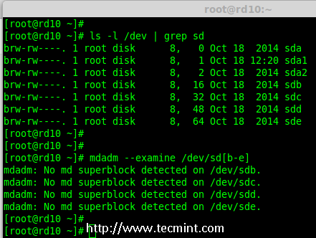

Verify 4 Added Disks

**Note**: In the above output, you see there isn’t any super-block detected yet, that means there is no RAID defined in all 4 drives.

#### **Step 1: Drive Partitioning for RAID**

**3.** Now create a new partition on all 4 disks (/dev/sdb, /dev/sdc, /dev/sdd and /dev/sde) using the ‘fdisk’ tool.

# fdisk /dev/sdb

# fdisk /dev/sdc

# fdisk /dev/sdd

# fdisk /dev/sde

##### **Create /dev/sdb Partition**

Let me show you how to partition one of the disk (/dev/sdb) using fdisk, this steps will be the same for all the other disks too.

# fdisk /dev/sdb

Please use the below steps for creating a new partition on **/dev/sdb** drive.

1. Press ‘**n**‘ for creating new partition.
2. Then choose ‘**P**‘ for Primary partition.
3. Then choose ‘**1**‘ to be the first partition.
4. Next press ‘**p**‘ to print the created partition.
5. Change the Type, If we need to know the every available types Press ‘**L**‘.
6. Here, we are selecting ‘**fd**‘ as my type is RAID.
7. Next press ‘**p**‘ to print the defined partition.
8. Then again use ‘**p**‘ to print the changes what we have made.
9. Use ‘**w**‘ to write the changes.

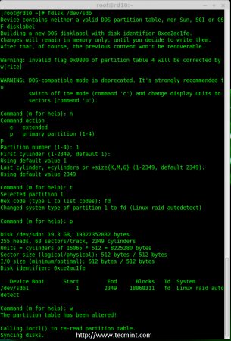

Disk sdb Partition

**Note**: Please use the above same instructions for creating partitions on other disks (sdc, sdd sdd sde).

**4.** After creating all 4 partitions, again you need to examine the drives for any already existing raid using the following command.

# mdadm -E /dev/sd[b-e]

# mdadm -E /dev/sd[b-e]1

OR

# mdadm --examine /dev/sdb /dev/sdc /dev/sdd /dev/sde

# mdadm --examine /dev/sdb1 /dev/sdc1 /dev/sdd1 /dev/sde1

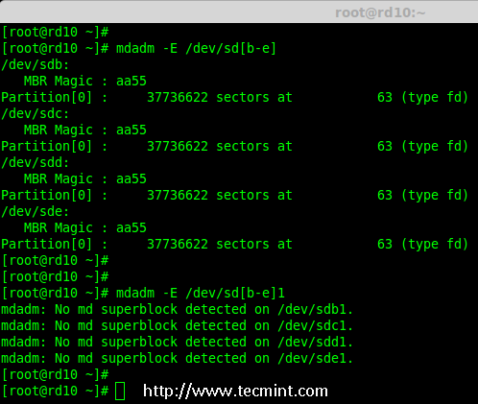

Check All Disks for Raid

**Note**: The above outputs shows that there isn’t any super-block detected on all four newly created partitions, that means we can move forward to create RAID 10 on these drives.

#### **Step 2: Creating ‘md’ RAID Device**

**5.** Now it’s time to create a ‘md’ (i.e. /dev/md0) device, using ‘mdadm’ raid management tool. Before, creating device, your system must have ‘mdadm’ tool installed, if not install it first.

# yum install mdadm [on RedHat systems]

# apt-get install mdadm [on Debain systems]

Once ‘mdadm’ tool installed, you can now create a ‘md’ raid device using the following command.

# mdadm --create /dev/md0 --level=10 --raid-devices=4 /dev/sd[b-e]1

**6.** Next verify the newly created raid device using the ‘cat’ command.

# cat /proc/mdstat

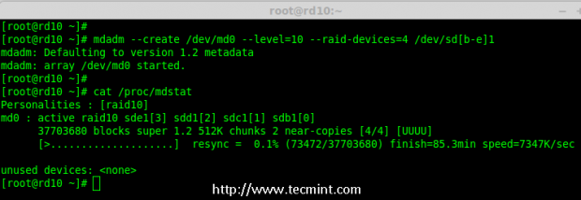

Create md raid Device

**7.** Next, examine all the 4 drives using the below command. The output of the below command will be long as it displays the information of all 4 disks.

# mdadm --examine /dev/sd[b-e]1

8. Next, check the details of Raid Array with the help of following command.

# mdadm --detail /dev/md0

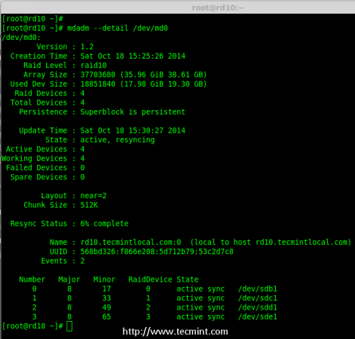

Check Raid Array Details

**Note**: You see in the above results, that the status of Raid was active and re-syncing.

#### **Step 3: Creating Filesystem**

**9.** Create a file system using ext4 for ‘md0’ and mount it under ‘**/mnt/raid10**‘. Here, I’ve used ext4, but you can use any filesystem type if you want.

# mkfs.ext4 /dev/md0

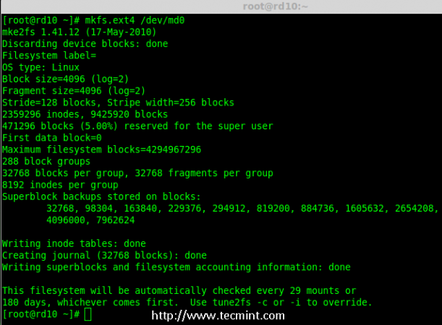

Create md Filesystem

**10.** After creating filesystem, mount the created file-system under ‘**/mnt/raid10**‘ and list the contents of the mount point using ‘ls -l’ command.

# mkdir /mnt/raid10

# mount /dev/md0 /mnt/raid10/

# ls -l /mnt/raid10/

Next, add some files under mount point and append some text in any one of the file and check the content.

# touch /mnt/raid10/raid10_files.txt

# ls -l /mnt/raid10/

# echo "raid 10 setup with 4 disks" > /mnt/raid10/raid10_files.txt

# cat /mnt/raid10/raid10_files.txt

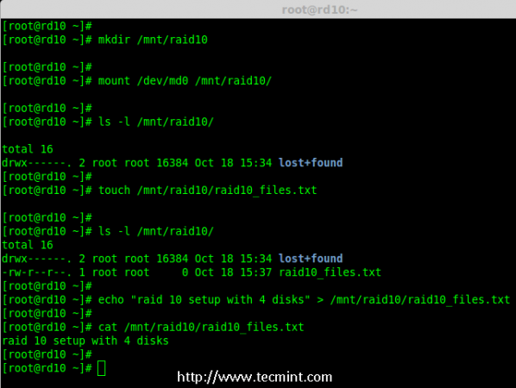

Mount md Device

**11.** For automounting, open the ‘**/etc/fstab**‘ file and append the below entry in fstab, may be mount point will differ according to your environment. Save and quit using wq!.

# vim /etc/fstab

/dev/md0 /mnt/raid10 ext4 defaults 0 0

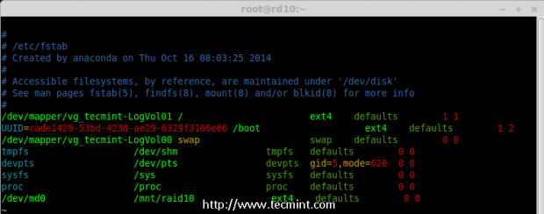

AutoMount md Device

**12.** Next, verify the ‘**/etc/fstab**‘ file for any errors before restarting the system using ‘**mount -a**‘ command.

# mount -av

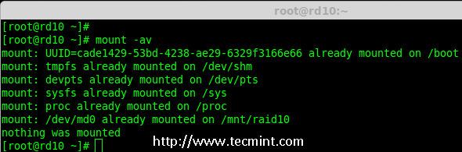

Check Errors in Fstab

#### **Step 4: Save RAID Configuration**

**13.** By default RAID don’t have a config file, so we need to save it manually after making all the above steps, to preserve these settings during system boot.

# mdadm --detail --scan --verbose >> /etc/mdadm.conf

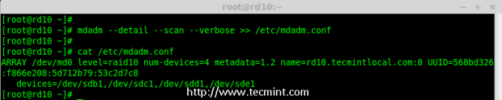

Save Raid10 Configuration

That’s it, we have created RAID 10 using method 1, this method is the easier one. Now let’s move forward to setup RAID 10 using method 2.

### **Method 2: Creating RAID 10**

**1.** In method 2, we have to define 2 sets of RAID 1 and then we need to define a RAID 0 using those created RAID 1 sets. Here, what we will do is to first create 2 mirrors (RAID1) and then striping over RAID0.

First, list the disks which are all available for creating RAID 10.

# ls -l /dev | grep sd

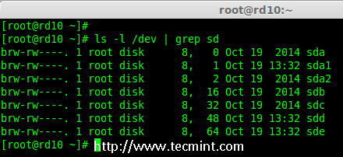

List 4 Devices

**2.** Partition the all 4 disks using ‘fdisk’ command. For partitioning, you can follow **#step 3** above.

# fdisk /dev/sdb

# fdisk /dev/sdc

# fdisk /dev/sdd

# fdisk /dev/sde

**3.** After partitioning all 4 disks, now examine the disks for any existing raid blocks.

# mdadm --examine /dev/sd[b-e]

# mdadm --examine /dev/sd[b-e]1

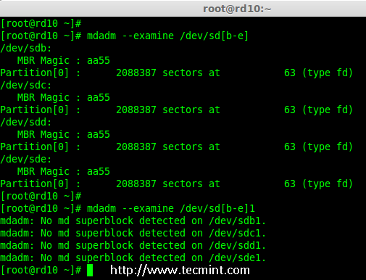

Examine 4 Disks

#### **Step 1: Creating RAID 1**

**4.** First let me create 2 sets of RAID 1 using 4 disks ‘sdb1’ and ‘sdc1’ and other set using ‘sdd1’ & ‘sde1’.

# mdadm --create /dev/md1 --metadata=1.2 --level=1 --raid-devices=2 /dev/sd[b-c]1

# mdadm --create /dev/md2 --metadata=1.2 --level=1 --raid-devices=2 /dev/sd[d-e]1

# cat /proc/mdstat

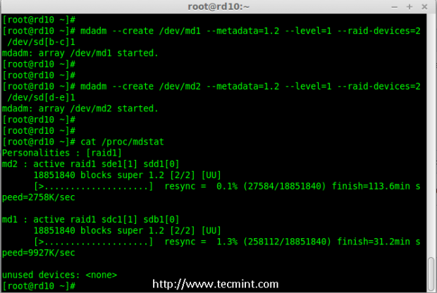

Creating Raid 1

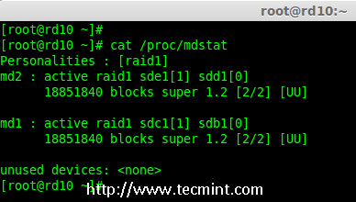

Check Details of Raid 1

#### **Step 2: Creating RAID 0**

**5.** Next, create the RAID 0 using md1 and md2 devices.

# mdadm --create /dev/md0 --level=0 --raid-devices=2 /dev/md1 /dev/md2

# cat /proc/mdstat

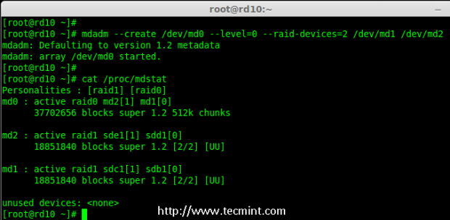

Creating Raid 0

#### **Step 3: Save RAID Configuration**

**6.** We need to save the Configuration under ‘**/etc/mdadm.conf**‘ to load all raid devices in every reboot times.

# mdadm --detail --scan --verbose >> /etc/mdadm.conf

After this, we need to follow #step 3 Creating file system of method 1.

That’s it! we have created RAID 1+0 using method 2. We will loose two disks space here, but the performance will be excellent compared to any other raid setups.